

**Eagle Absence Registration**

**Installation and Deployment Guide**

Table of Contents

1.Introduction 3

1.1 Purpose 3

1.2 Revision history 3

2.References 3

3.Definitions, acronyms and abbreviations 3

4.Software installation 4

4.1 EEM Services installation 4

4.1.1 API Installation 4

4.2 Application installation 5

# 1.Introduction

## 1.1 Purpose

The purpose of this Installation and Deployment Guide is to describe in technical terms the steps necessary to install the Eagle Absence Registration software and make it operational.

## 1.2 Revision history

The Revision history table shows the date, changes, and authors who have worked on this document.

|  |  |  |  |
| --- | --- | --- | --- |
| Version/Change request number | Version date | Description of changes | Author |
| 1 | 04/16/2018 | First Draft | Jefferson Dhanasingh |

# 2.References

|  |  |  |
| --- | --- | --- |
| Reference No. | Document | Author(s) |
| REF-1 | [Microsoft .NET Framework 4 (Standalone Installer)](http://www.microsoft.com/download/en/details.aspx?displaylang=en&id=17718) | Microsoft |

# 3.Definitions, acronyms and abbreviations

|  |  |
| --- | --- |
| Term | Definition |
| Administrator | This is anyone from the client that has been given administrative rights in the Eagle Absence Registration. |
| IIS | Microsoft Internet Information Server |

# 4.Software installation

## 4.1 EEM Services installation

1. Download absence_registration.rar file from the following location.

<https://github.com/EagleShare/EEM/tree/Week-of-09-April-2018/2018-04-13>

1. If you unzip the folder you would see an EEM Services Installation folder. Copy the contents of this folder into the EEMServices folder present inside the EEM binary folder
2. It would ask for sure to replace the web.config. Click yes and replace.
3. Now run the Setup.cmd file which is in the EEMServices folder.

## 4.2 IIS Configuration

1. Login into the Windows Server Box where EEM is hosted.
2. Go to the folder where the EEM binary is located and hosted in the IIS
3. Check whether EEMServices folder is present in the location.
4. Log into IIS
5. In the left pane of the IIS there is a tree structure with Computer name and sites branch below.
6. Right click on the Sites node and select add website.
7. Now give the site name as EEMServices, select application pool to default app pool.
8. Now map the path to the EEMServices folder.
9. Setup an external IP/DNS mapping to this folder that you can access it over the internet.
10. Select a valid port number which can be accessed over the internet.
11. Run google chrome and browse the newly created website using the IIS browse website link to ensure it does not display an error. If you see an error, it means you have chosen an unsafe port so change the port number and retry. The following is the sample screen which ensures you have the right port.

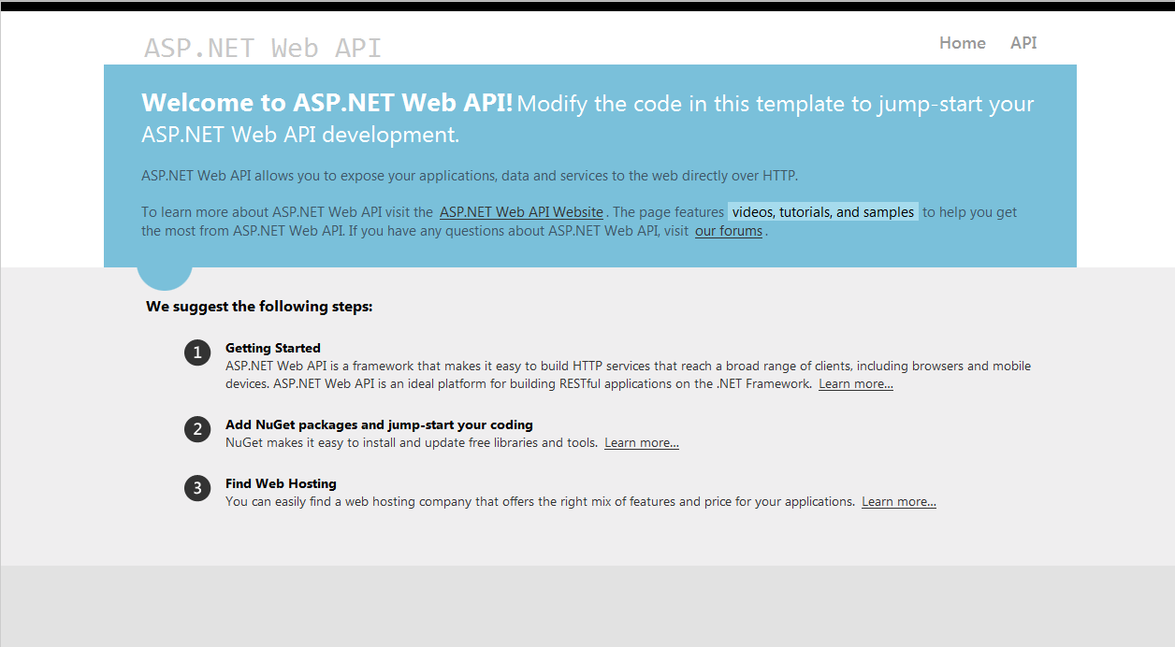

## 4.3 Application installation

1. Create a new folder called "EEM Absence Register" under EEM main folder where all EEM applications like UAT, EEM Applications exists.
2. In the extracted file from step 4.1.2, spot the absence UI binary folder and copy the contents into the above created folder.
3. Run the Setup.cmd present in the new folder and a command prompt will appear as below.

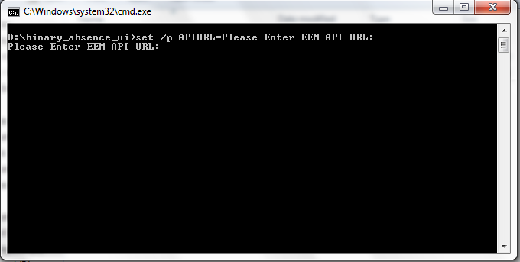

1. Now enter the new website with port that was created in step 4.2.9.
2. Log into IIS
3. In the left pane of the IIS there is a tree structure with Computer name and sites branch below.
4. Right click on the Sites node and select add website.
5. Now give the site name as Absence Register, select application pool to default app pool.
6. Now map the path to the EEM Absence Register folder.
7. Setup an external IP/DNS mapping to this folder that you can access it over the internet.
8. Select a valid port number which can be accessed over the internet.
9. Run google chrome and browse the newly created website using the IIS browse website link to ensure it does not display an error. If you see an error, it means you have chosen an unsafe port so change the port number and retry. The following is the sample screen which ensures you have the right port.

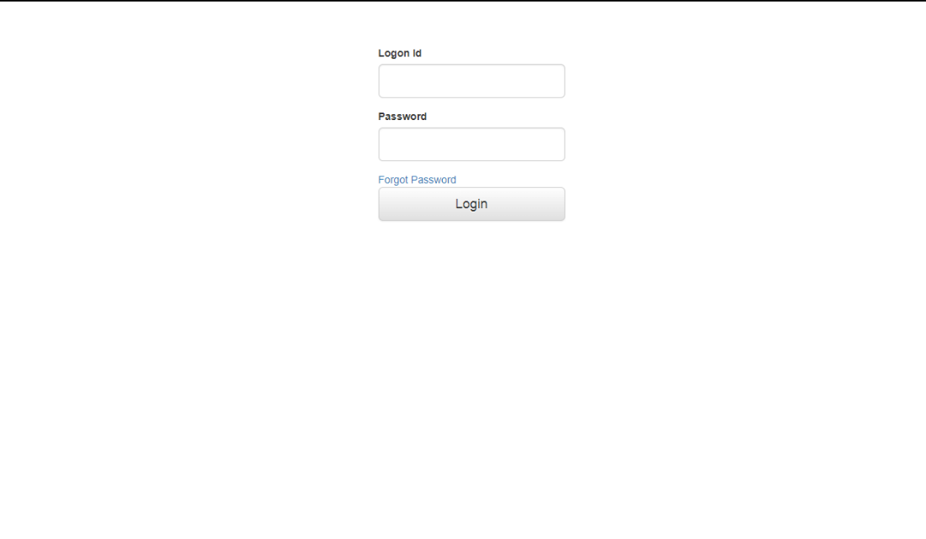

# 5.Application Usage

1. This website is designed on the base of the absence registration available in the EEM module.
2. This website has the advantage compatibility to all the browsers except Internet explorer also it can be accessed through mobile phones too.
3. Following screen is for login and it needs to be logged in with the credentials provided for EEM login



1. Forgot passwords sends an email to the registered office email id through which password can be reset.
2. Following is the screen to apply absence.

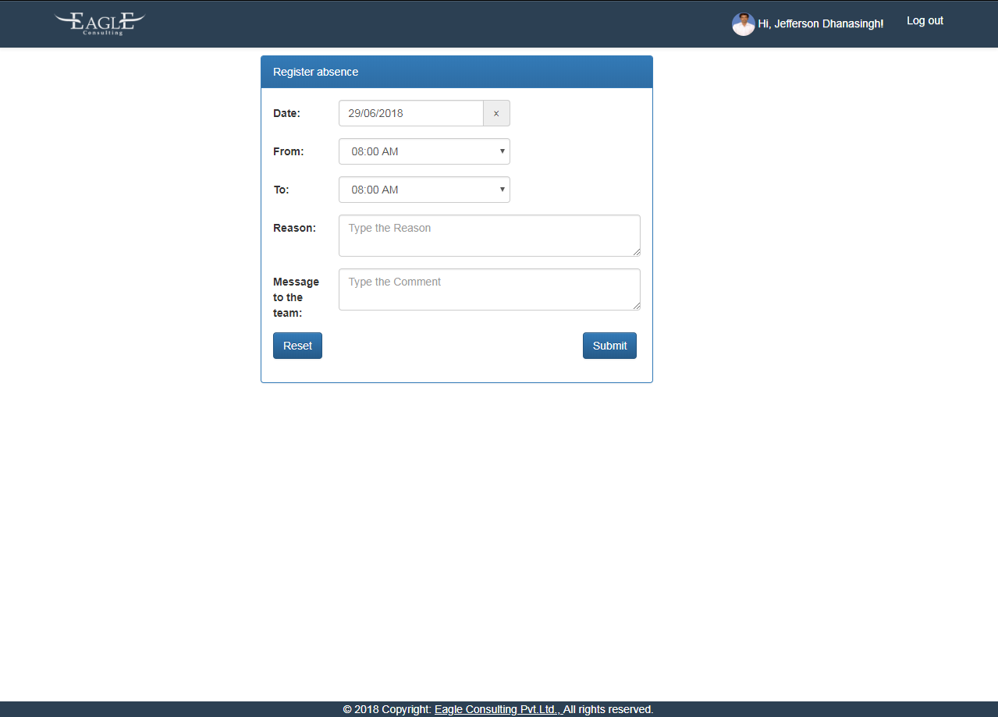

1. Fill in the details with appropriate date, time with reason and comments. Date time and reason are mandatory fields.
2. If the permission hour exceeds 2 hrs the screen changes to apply leave mode. Refer below image for it.

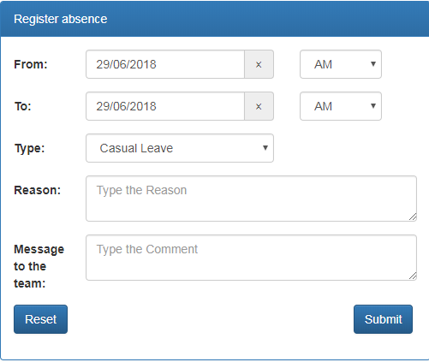

1. Reset button is to be used to move back to permission mode. Submit button submits the request.
2. On Click of employee name we bring up the details of the employee who is logged in.

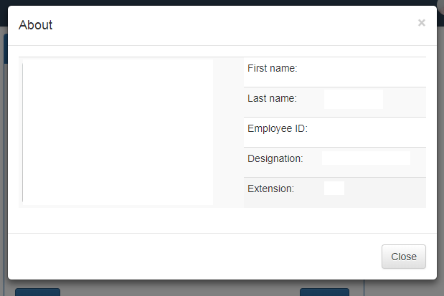

1. Logout logs you out of the account.